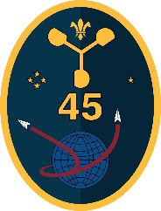
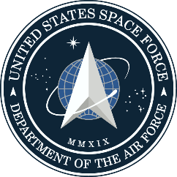
 |  |  |  | Launch Mission Execution Forecast
 |  |  |  | Mission: |  | Falcon 9 Starlink g12-16
 |  |  |  | Issued: |  | 14 Mar 2025 / 0930L (1330Z)
 |  |  |  | Valid: |  | 15 Mar 2025 / 0628 – 1028L (1028 – 1428Z)
Forecast Discussion: High pressure across the Western Atlantic will continue dry weather across the Spaceport Saturday morning, however a strengthening pressure gradient from a cold front approaching the Deep South will strengthen winds from the Southeast. These winds will generate a very small POV for the primary launch window.

Conditions begin to deteriorate Sunday as the cold front moves into the FL Panhandle. While showers are not yet expected across the Spaceport for the backup launch window, winds will further strengthen, and cumulus clouds will increase across the area. Liftoff Winds will be the main concern for the backup launch window, with only a small concern of a Cumulus Cloud Rule violation.
Launch Day | Probability of Violating Weather Constraints¹
 | <5% | Primary Concerns: Liftoff Winds
 | Weather Conditions |  |  |  |  |  |  |  |  |  | Additional Risk Criteria²
 | Weather/Visibility: |  | None / 7 mi. |  |  |  | Clouds |  |  |  | Upper-Level Wind Shear: |  | Low
 |  |  |  |  |  |  | Type | Coverage | Base (ft) | Tops (ft)
 | Temp/Humidity: |  | 66°F / 98% |  |  |  | Cumulus | Few | 3,000 | 6,000 | Booster Recovery Weather: |  | Low
 | Liftoff Winds (200’): |  | 150° 18 - 23 mph |  |  |  |  |  |  |  | Solar Activity: |  | Low
24-Hour Delay | Probability of Violating Weather Constraints
 | 30% | Primary Concerns: Liftoff Winds, Cumulus Cloud Rule
 | Weather Conditions |  |  |  |  |  |  |  |  |  | Additional Risk Criteria
 | Weather/Visibility: |  | None / 7 mi. |  |  |  | Clouds |  |  |  | Upper-Level Wind Shear: |  | Low
 |  |  |  |  |  |  | Type | Coverage | Base (ft) | Tops (ft)
 | Temp/Humidity: |  | 68°F / 93% |  |  |  | Cumulus | Scattered | 2,500 | 9,000 | Booster Recovery Weather: |  | Low
 | Liftoff Winds (200’): |  | 170° 25 - 35 mph |  |  |  |  |  |  |  | Solar Activity: |  | Low
Notes | - The Probability of Violation (PoV) is the chance of a local safety or customer constraint violation occurring any random time during the launch window.  - Additional Risk Criteria, which are not included in the PoV, are mission-specific constraints that may not include all phenomena within each risk factor.  See https://www.patrick.spaceforce.mil/Portals/14/Weather/LaunchFAQ.pdf for more information
Next Forecast Will Be Issued |  |  |  |  | As Required

